
June 14, 2024
FOR MORE INFORMATION CONTACT: Phil Brylow
Visual Media Awards Committee Chair
International Bowling Media Association (IBMA)
Email: phil.brylow@tenonthedeck.com

Inaugural IBMA Visual Media Awards Announced;
Goodger, McLean Pace 2023 Winners
Arlington, Texas – Jef Goodger of the Professional Bowlers Association, along with Chad McLean from Storm Bowling, are the recipients of the most individual honors for the inaugural IBMA Visual Media Awards, that comprised of works published during the 2023 calendar year.

Goodger, a multiple-time award winner in previous IBMA Writing Award competitions, received three awards, a first place in Livestream Tournament Coverage with producing the “USA Vs. the World” livestream from historic Holler House in Milwaukee, Wisconsin along with first and second place awards in the News Feature / Documentary category.
McLean received first and third place awards in the Still Photography / Artistic category, for photos used in social media for Storm Bowling.

Five IBMA members earned awards in the competition.
All winners will be recognized at the Internation Bowling Media booth at the 2024 Bowl Expo Trade Show on July 1 & 2 in Aurora, Colorado.

2023 IBMA Visual Media Award Winners

LIVESTREAM TOURNAMENT COVERAGE
1st Place – “USA Vs. the World”
PBA (Jef Goodger, Producer)
SEE VIDEO HERE

NEWS FEATURE / DOCUMENTARY VIDEO
1st Place – “World Series of Bowling XIV Chronicles / Episode 1 / PBA Cheetah Championship Qualifying”
PBA (Jef Goodger, Producer)
SEE VIDEO HERE

2nd Place – “PBA Triple Crown Chase / EJ Tackett at the 2023 U.S. Open”
PBA (Jef Goodger, Producer)
SEE VIDEO HERE

3rd Place – “Jason Belmonte at the Masters with #TeamLSR”
Robert Johnson, Producer
SEE VIDEO HERE

PODCAST
No Awards

NOTE: Right Mouse Click on the Video Links to open in your browser

STILL PHOTOGRAPHY – ARTISTIC
TIE - 1ST Place – “The Pour”
Instagram – “How It’s Made” - Chad McLean
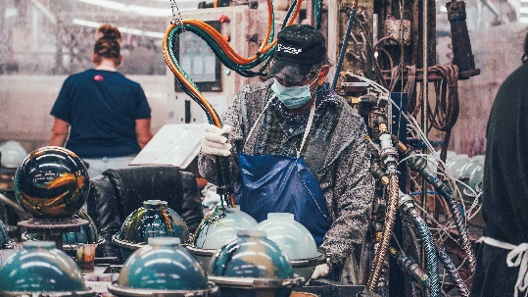
“Miracle Lanes, Sidney, BC”
“Maple and Pine” - Kevin Hong
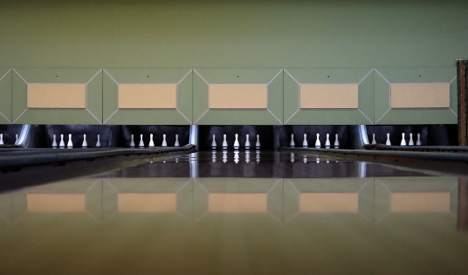
3rd Place - “Shiny”
Instagram “How It’s Made” - Chad McLean
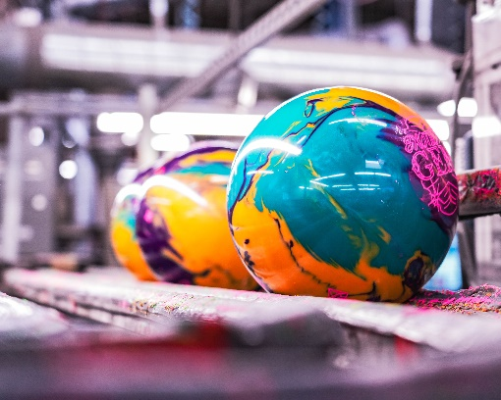

STILL PHOTOGRAPHY – NEWS FEATURE / DOCUMENTARY ACCOMPANIMENT
1st Place – “Marriage Proposal on the Lanes at Xtravaganza
Bowling Center Management 8/2023 - Michelle Johnson




